**A-10.**

**Capacitors**

**OBJECTIVES**

After performing this experiment, you will be able to:

1. Compare total capacitance, charge, and voltage drop for capacitors connected in series and in parallel.

2. Test capacitors with an ohmmeter and a voltmeter.

3. Determine the value of small capacitors from coded markings.

**READING**

Nilsson, Electric Circuits, Section 6.2 The Capacitor

**MATERIALS NEEDED:**

Two LEDs Resistors:

Two 1.0 kΩ Capacitors:

One of each : 100 μF, 47μF, 1.0 μF, 0.1 μF, 0.01μF (35 WV or greater)

**SUMMARY OF THEORY**

A capacitor is formed whenever two conductors are separated by an insulating material. When a voltage exists between the conductors, there will be an electric charge between the conductors. The ability to store an electric charge is a fundamental property of capacitors and affects both dc and ac circuits. Capacitors are made with large flat conductors called plates. The plates are separated with an insulating material called a dielectric. The ability to store charge increases with larger plate size and closer separation.

When a voltage is connected across a capacitor, charge will flow in the external circuit until the voltage across the capacitor is equal to the applied voltage. The charge that flows is proportional to the size of the capacitor and the applied voltage. This is a fundamental concept for capacitors and is given by the equation

Q = CV

where Q is the charge in coulombs, C is the capacitance in farads, and V is the applied voltage. An analogous situation is that of putting compressed air into a bottle. The quantity of air is directly proportional to the capacity of the bottle and the applied pressure. (In this analogy, pressure is like voltage, the capacity of the bottle is like capacitance, and the amount of air is like charge.)

Recall that current is defined as charge per time. That is,

$$I=\frac{Q}{t}$$

where I is the current in amperes, Q is the charge in coulombs, and t is the time in seconds. This equation can be rearranged as

Q = It

If we connect two capacitors in series with a voltage source, the same charging current is through both capacitors. Since this current is for the same amount of time, the total charge, QT, must be the same as the charge on each capacitor. That is,

$$Q_{T}=Q_{1}=Q_{2}$$

Charging capacitors in series causes the same charge to be across each capacitor; however, as shown in the text, the total capacitance decreases. In a series circuit, the total capacitance is given by the formula:

$$\frac{1}{C_{T}}=\frac{1}{C_{1}}+\frac{1}{C_{2}}+⋯+\frac{1}{C_{n}}$$

Now consider capacitors in parallel. In a parallel circuit, the total current is equal to the sum of the currents in each branch as stated by Kirchhoff’s current law. If this current is for the same amount of time, the total charge leaving the voltage source will equal the sum of the charges which flow in each branch. That is,

$$Q_{T}=Q_{1}+Q_{2}+⋯+Q_{n}$$

Capacitors connected in parallel will raise the total capacitance because more charge is stored at the same voltage. The equation for the total capacitance of parallel capacitors is:

$$C_{T}=C_{1}+C_{2}+⋯+C_{n}$$

There are two quick tests you can make to check capacitors. The first is an ohmmeter test, useful for capacitors larger than 0.01 μF. This test is best done with an analog ohmmeter rather than a digital meter. The test will sometimes indicate a faulty capacitor is good; however, you can be sure that if a capacitor fails the test, it is bad. The test is done as follows:

1. Remove one end of the capacitor from the circuit and discharge it by placing a short across its terminals.

2. Set the ohmmeter on a high-resistance scale and place the negative lead from an ohmmeter on the negative terminal of the capacitor. You must connect the ohmmeter with the proper polarity. Do not assume the common lead from the ohmmeter is the negative side!

3. Touch the other lead of the ohmmeter onto the remaining terminal of the capacitor. The meter should indicate very low resistance and then gradually increase resistance. If you put the meter in a higher range, the ohmmeter charges the capacitor slower and the capacitance “kick” will be emphasized. For small capacitors (under 0.01 μF), this charge may not be seen. Large electrolytic capacitors require more time to charge, so use a lower range on your ohmmeter. Capacitors should never remain near zero resistance, as this indicates a short. An immediate high resistance reading indicates an open for larger capacitors.

A capacitor that passes the ohmmeter test may still fail when voltage is applied. A voltmeter can be used to check a capacitor with voltage applied. The voltmeter is connected in series with the capacitor. When voltage is first applied, the capacitor charges. As it charges, voltage will appear across it, and the voltmeter indication should be a very small voltage. Large electrolytic capacitors may have leakage current that makes them appear bad, especially with a very high impedance voltmeter. As in the case of the ohmmeter test, small capacitors may charge so quickly they appear bad. In these cases, use the test as a relative test, comparing the reading with a similar capacitor that you know is good. Ohmmeter and voltmeter tests are never considered comprehensive tests but are indicative that a capacitor is capable of being charged.

Capacitor Identification

There are many types of capacitors available with a wide variety of specifications for size, voltage rating, frequency range, temperature stability, leakage current, and so forth. For general-purpose applications, small capacitors are constructed with paper, ceramic, or other insulation material and are not polarized. Three common methods for showing the value of a small capacitor are shown in Figure 1. In Figure 1 (a), a coded number is stamped on the capacitor that is read in pF. The first two digits represent the first two digits, the third number is a multiplier. For example, the number 473 is a 47000 pF capacitor. Figure 1 (b) shows the actual value stamped on the capacitor in μF. In the example shown, .047 μF is the same as 47000 pF. In Figure 1 (c), a ceramic color-coded capacitor is shown that is read in pF. Generally, when 5 colors are shown, the first is a temperature coefficient (in ppm/°C with special meanings to each color). The second, third, and fourth colors are read as digit 1, digit 2, and a multiplier. The last color is the tolerance. Thus a 47000 pF capacitor will have a color representing the temperature coefficient followed by yellow, violet, and orange bands representing the value. Unlike resistors, the tolerance band is generally green for 5% and white for 10%. More information on capacitor color codes is given in the text in Appendix B.

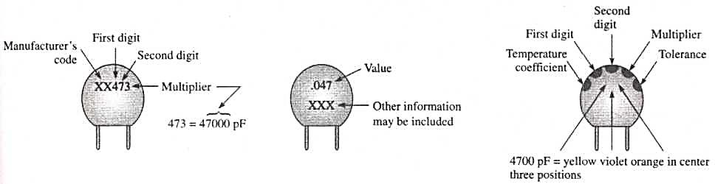

|  |  |  |
| --- | --- | --- |
| (a) Coded value | (b) Stamped value(in pF or μF) | (c) Color code |
| **Figure 1** | | |

Larger electrolytic capacitors will generally have their value printed in uncoded form on the capacitor and a mark indicating either the positive or negative lead. They also have a maximum working voltage printed on them which must not be exceeded. Electrolytic capacitors are always polarized, and it is very important to place them into a circuit in the correct direction based on the polarity shown on the capacitor. They can overheat and explode if placed in the circuit backwards.

**PROCEDURE**

1. Obtain five capacitors as listed in Table 1. Check each capacitor using the ohmmeter test described in the Summary of Theory. Record the results of the test in Table 1.

2. Test each capacitor using the voltmeter test as illustrated in Figure 2. Large electrolytic capacitors or very small capacitors may appear to fail this test, as mentioned in the Summary of Theory. Check the voltage rating on the capacitor to be sure it is not exceeded. The working voltage is the maximum voltage that can safely be applied to the capacitor. Record your results in Table 1.

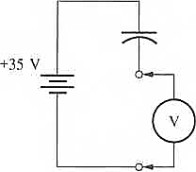

Figure 2

3. Connect the circuit shown in Figure 3. The switches can be made from jumper wires. Leave both switches open. The light-emitting diodes (LEDs) and the capacitor are both polarized components—they must be connected in the correct direction in order to work properly.

4. Close *S1* and observe the LEDs. Describe your observation in Table 2.

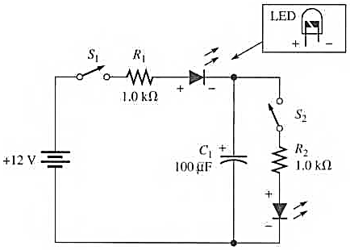

Figure 3

5. Open *S1* and then close S2. Describe your observation in Table 2.

6. Now connect C2 in series with *C1* Open S2. Make certain the capacitors are fully discharged by shorting them with a piece of wire; then close S1. Measure the voltage across each capacitor. Do this quickly to prevent the meter from causing the capacitors to discharge. Record the voltages in Table 2.

V1= V2 =

7. Using the measured voltage, compute the charge on each capacitor. Then open *S1* and close *S2*. Record the compute charge and your observations in Table 2.

Q1= Q2 =

8. Change the capacitors from series to parallel. Ensure that the capacitors are fully discharged. Open S2 and close S1. Measure the voltage (quickly) across the parallel capacitors and enter the measured voltage in Table 2.

V1= V2 =

9. Using the measured voltage across the parallel capacitors, compute the charge on each one. Then open *S1* and close *S2*. Record the computed charge and your observations in Table 2.

Q1= Q2 =

10. Replace the 12 V dc source with a signal generator. Close both S1 and S2 . Set the signal generator to a square wave and set the amplitude to 12 Vpp. Set the frequency to 10 Hz. Notice the difference in the LED pulses. This demonstrates one of the principal applications of large capacitors—that of filtering. Record your observations.

|  |  |
| --- | --- |
| **Report for**  **Experiment A-10** | **Name**  **Date**  **Class** |

**ABSTRACT:**

**DATA:**

**Table 1**

|  |  |  |  |
| --- | --- | --- | --- |
| **Capacitor** | **Listed**  **Value** | **Ohmmeter Test Pass/Fail** | **Voltmeter Test Pass/Fail** |
| C1 | 100 μF |  |  |
| C2 | 47 μF |  |  |
| C3 | 1.0 μF |  | | |
| C4 | 0.1 μF |  |  |
| C5 | 0.01 μF |  |  |

Table 2

|  |  |  |  |  |  |
| --- | --- | --- | --- | --- | --- |
| **Step** | **V1** | **V2** | **Q1** | **Q2** | **Observations** |
| 4 |  |  |  |  |  |
| 5 |  |  |  |  |  |
| 6 |  |  |  |  |  |
| 7 |  |  |  |  |  |
| 8 |  |  |  |  |  |
| 9 |  |  |  |  |  |
| 10 |  |  |  |  |  |

**RESULT AND CONCLUSION:**

**EVALUATION AND REVIEW QUESTIONS**

1. Why did the LEDs flash for a shorter time in step 6 than in steps 4 and 5?

2. What would happen if you added more series capacitance in step 6?

3. (a) What is the total capacitance when a 1.0 pF capacitor is connected in parallel with a 2.0 pF capacitor?

(b) If the capacitors are connected in series, what is the total capacitance?

(c) In the series connection, which capacitor has the greater voltage across it?

4. Determine the value in pF and pF for each small capacitor with the coded numbers as shown:

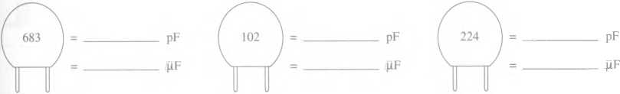

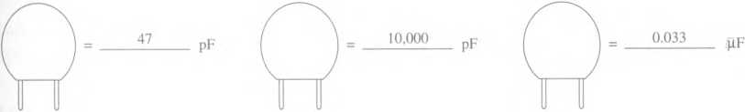5. Write the coded number that should appear on each capacitor for the values shown: